

**MSPM’S**

**Deogiri Institute of Engineering and Management Studies, Aurangabad**

**Department of Computer Science and Engineering**

Report on

**LAPTOPS**

**Pandey Raj and Pathak Atharva**

**CSE-B (26107&26108)**

**Prof. Pankaj Durole**

Prof. Department of Computer Science and Engineering



**CERTIFICATE**

This is to certify that Mr. Pandey Raj and Pathak Atharva has Completed report of CAO on Laptops. For the partial fulfillment of Continuous Assessment on date_6/09/2019

**Name and Signature of Student Name and Signature of Subject Teacher**

Device Name: HP-da0077 TX

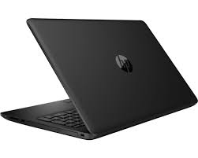

**Processor architecture**

Core i5-8265U is a 64-bit quad-core performance x86 mobile microprocessor introduced by Intel in mid-2018.

This processor, which is based on an enhanced version of the Whiskey Lake microarchitecture, is manufactured on Intel's 3rd generation enhanced 14nm++ process.

**BASIC INFORMATION**

Model name: HP-da0077 TX

Operating system (with version): DOS

Laptop type: Ultra-portal

Microprocessor **:** Intel® Core™ i5-8265U (1.6 GHz base frequency, up to 3.4GHz with Intel® Turbo Boost Technology, 6 MB cache, 4 cores)

**Specifications**

General

|  |  |
| --- | --- |
| Sales Package | * Laptop, Battery, Power Adaptor, User Guide, Warranty Documents |
| Model Number | * 15-da0077tx |
| Part Number | * 4TT02PA#ACJ |
| Series | * 15 |
| Color | * Sparkling Black |
| Type | * Laptop |
| Suitable For | * Processing & Multitasking |
| Power Supply | * 65 W AC Adapter |
| Battery Cell | * 3 cell |
| MS Office Provided | * No |

Processor and Memory Features

|  |  |
| --- | --- |
| Dedicated Graphic Memory Type | * GDDR5 |
| Dedicated Graphic Memory Capacity | * 2 GB |
| Processor Brand | * Intel |
| Processor Name | * Core i5 |
| Processor Generation | * 8th Gen |
| SSD | * No |
| RAM | * 8 GB |
| RAM Type | * DDR4 |
| HDD Capacity | * 1 TB |
| Processor Variant | * 8250U |
| Clock Speed | * 1.6 GHz with Turbo Boost Up to 3.4 GHz |
| RAM Frequency | * 2400 MHz |
| Cache | * 6 MB |
| RPM | * 5400 |
| Graphic Processor | * NVIDIA GeForce MX110 |
| Number of Cores | * 4 |

Operating System

|  |  |
| --- | --- |
| Operating System | * DOS |

Port and Slot Features

|  |  |
| --- | --- |
| Mic In | * Yes |
| RJ45 | * Yes |
| USB Port | * 1 x USB 2.0, 2 x USB 3.1 |
| HDMI Port | * 1 x HDMI Port (v1.4b) |
| Multi Card Slot | * 3-in-1 Card Reader (SD, SDHC, SDXC) |
| Hardware Interface | * SATA |

Display and Audio Features

|  |  |
| --- | --- |
| Touchscreen | * No |
| Screen Size | * 39.62 cm (15.6 inch) |
| Screen Resolution | * 1920 x 1080 Pixel |
| Screen Type | * Full HD LED Backlit Anti-glare Display |
| Speakers | * Built-in Dual Speakers |
| Internal Mic | * Built-in Digital Microphone |

Connectivity Features

|  |  |
| --- | --- |
| Wireless LAN | * IEEE 802.11b/g/n |
| Bluetooth | * v4.2 |
| Ethernet | * Integrated 10/100/1000 Gigabit LAN |

Dimensions

|  |  |
| --- | --- |
| Dimensions | * 376 x 246 x 22.5 mm |
| Weight | * 1.77 kg |

Additional Features

|  |  |
| --- | --- |
| Disk Drive | * CD/DVD writer |
| Web Camera | * HP True Vision HD Webcam |
| Read/Write Speed | * 8x |
| Keyboard | * Full Size Island-style Keyboard with Numeric Keypad |
| Pointer Device | * Multi Gesture Touchpad |
| Additional Features | * Li-ion Battery |

Warranty

|  |  |
| --- | --- |
| Warranty Summary | * 1 Year Onsite Warranty |
| Warranty Service Type | * Onsite |
| Covered in Warranty | * Manufacturing Defects |
| Not Covered in Warranty | * Physical Damage |
| Domestic Warranty | * 1 Year |

|  |
| --- |
| **Memory & Storage**  1. HDD  Memory is the most essential element of a computing system because without it  Computer can’t perform simple tasks. Computer memory is of two basic type – Primary  memory / Volatile memory and Secondary memory / non-volatile memory. Random  Access Memory (RAM) is volatile memory and Read Only Memory (ROM) is non-  volatile memory.  1. Random Access Memory (RAM) –  • It is also called as read write memory or the main memory or the primary  memory.  • The programs and data that the CPU requires during execution of a program are  stored in this memory.  • It is a volatile memory as the data loses when the power is turned off.  • RAM is further classified into two types- SRAM (Static Random Access  Memory) and DRAM (Dynamic Random Access Memory).  2. Read Only Memory (ROM) –  • Stores crucial information essential to operate the system, like the program  essential to boot the computer.  • It is not volatile.  • Always retains its data.  • Used in embedded systems or where the programming needs no change.  • Used in calculators and peripheral devices.  • ROM is further classified into 4 types- ROM, PROM, EPROM, and EEPROM.  Types of Read Only Memory (ROM) –  1. PROM (Programmable read-only memory) – It can be programmed by user.  Once programmed, the data and instructions in it cannot be changed.  2. EPROM (Erasable Programmable read only memory) – It can be  reprogrammed. To erase data from it, expose it to ultra violet light. To  reprogram it, erase all the previous data.  3. EEPROM (Electrically erasable programmable read only memory) – The  data can be erased by applying electric field, no need of ultra violet light. We can  erase only portions of the chip  An SSD (solid-state drive) is a type of nonvolatile storage media that stores persistent  data on solid-state flash memory. Two key components make up an SSD: a flash  controller and NAND flash memory chips. The architectural configuration of the SSD  controller is optimized to deliver high read and write performance for both sequential  and random data requests. SSDs are sometimes referred to as flash drives or solid-  state disks.  SSDs will use three main types of memory:  1) Single cell  2) multi cell  3) triple-level cells  1) Single-level cells can hold one bit of data at a time—a one or zero. Single-level  cells (SLC) are the most expensive form of SSD, but it is also the fastest and most  durable.  2) Multi-level cells (MLC) can hold two bits of data per cell and have a larger  amount of storage space in the same amount of physical space as SLC. However,  MLCs have slower write speeds.  3) Triple-level cells (TLC) can hold three bits of data in a cell. TLCs have a lower  price, but slower write speeds and less durability. TLC-based SSDs deliver more  flash capacity and are cheaper than an MLC or SLC.  How data storage works?  The term *storage* may refer both to a user's data generally and, more specifically, to the integrated hardware and software systems used to capture, manage and prioritize the data. This includes information in applications, databases, data warehouses, archiving, backup appliances and cloud storage.  Digital information is written to target storage media through the use of software commands. The smallest unit of measure in a computer memory is a bit, described with a binary value of 0 or 1, according to the level of electrical voltage contained in a single capacitor. Eight bits make up one byte.  Other capacity measurements to know are:   * • kilobyte (KB) * • megabyte (MB) * • gigabyte (GB) * • terabyte (TB) * • petabyte (PB) * • Exabyte (EB)   Larger measures include:   * • kilobyte (KB) equal to 1,024 bytes * • megabyte (MB) equal to 1,024 KB * • gigabyte (GB) equal to 1,024 MB * • terabyte (TB) equal to 1,024 GB * • petabyte (PB) equal to 1,024 TB * • exabyte (EB) equal to 1,024 PB   Few organizations require a single storage system or connected system that can reach an exabyte of data, but there are storage systems that scale to multiple petabytes.  Data storage capacity requirements define how much storage is needed to run an application, a set of applications or data sets. Capacity requirements take into account the types of data. For instance, simple documents may only require kilobytes of capacity, while graphic-intensive files, such as digital photographs, may take up megabytes, and a video file can require gigabytes of storage. Computer applications commonly list the minimum and recommended capacity requirements needed to run them.  On an electromechanical disk, bytes store blocks of data within sectors. A hard disk is a circular platter coated with a thin layer of magnetic material. The disk is inserted on a spindle and spins at speeds of up to 15,000 revolutions per minute (rpm). As it rotates, data is written on the disk surface using magnetic recording heads. A high-speed actuator arm positions the recording head to the first available space on the disk, allowing data to be written in a circular fashion.  A sector on a standard disk is 512 bytes. Recent advances in disk include shingled magnetic recording, in which data writes occur in overlapping fashion to boost the platter's areal density.  On solid-state drives (SSDs), data is written to pooled NAND flash, designed with floating gate transistors that enable the cell to retain an electrical charge. An SSD is not technically a drive, but it exhibits design characteristics similar to an integrated circuit, featuring potentially millions of nano transistors placed on millimeter-sized silicon chips.  Backup data copies are written to disk appliances with the aid of a hierarchical storage management system. And although less commonly practiced than in years past, the tactic of some organizations remains to write disk-based backup data 23  to magnetic tape as a tertiary storage tier. This is a best practice in organizations subject to legal regulations.  A virtual tape library (VTL) uses no tape at all. It is a system in which data is written sequentially to disks, but retains the characteristics and properties of tape. The value of a VTL is its quick recovery and scalability.  Evaluating the storage hierarchy  Organizations increasingly use tiered storage to automate data placement on different storage media, based on an application's capacity, compliance and performance requirements.  Enterprise data storage is often classified as primary and secondary storage, depending on how the data is used and the type of media it requires. Primary storage handles application workloads central to a company's day-to-day production and main lines of business.  Primary storage is occasionally referred to as *main storage* or *primary memory*. Data is held in random access memory (RAM) and other built-in devices, such as the processor's L1 cache. Secondary storage encompasses data on flash, hard disk, tape and other devices requiring I/O operations. Secondary storage media is often used in backup and cloud storage.  Primary storage generally provides faster access than secondary storage due to the proximity of storage to the computer processor. On the other hand, secondary storage can hold much more data than primary storage. Secondary storage also replicates inactive data to a backup storage device, yet keeps it highly available in case it is needed again.  Digital transformation of business has prompted more and more companies to deploy multiple hybrid clouds, adding a remote tier to buttress local storage. 24  Types of data storage devices/mediums  Data storage media have varying levels of capacity and speed. These include cache memory, dynamic RAM (DRAM) or main memory; magnetic tape and magnetic disk; optical disc, such as CDs, DVDs and Blu-ray disks; flash memory and various iterations of in-memory storage; and cache memory.  Along with main memory, computers contain nonvolatile read-only memory (ROM), meaning data cannot be written to it.  The main types of storage media in use today include hard disk drives (HDDs), solid-state storage, optical storage and tape. Spinning HDDs use platters stacked on top of each other coated in magnetic media with disk heads that read and write data to the media. HDDs are widely used storage in personal computers, servers and enterprise storage systems, but SSDs are starting to reach performance and price parity with disk.  **HDMI-**  Stands: High-Definition Multimedia Interface.&quot; HDMI is a trademark and  brand name for a digital interface used to transmit audio and video data in a single  cable. It is supported by modern audio/video equipment. HDMI outputs &quot;feed&quot; audio  and video signals into the HDMI inputs of digital devices, which receive and process  them. The cables are terminated with plug connectors, typically featuring 19 pins.  Many A/V receivers contain digital processors that can take analog video signals, from  a VHS or DVD player, and convert them to HMDI.  **USB**  USB refers to Universal Serial Bus, which is a type of connection used to link  computers to peripheral devices. USB ports are found on both the computers and the  devices, and USB cables connect them to each other. USB ports function as both input  and output ports. There are two types of USB ports, Type A and Type B, and  Information can go both directions on either one.  USB Type A  The most popular type of USB standard is Type A. You will most likely to find Type-A  Ports in host devices like desktop computers, gaming consoles and media players.  USB Type B  Type-B connectors are at the other end of a typical USB cable that plugs into a  Peripheral device, such as a smartphone, a printer or a hard drive.  USB Type C  Type-C over other existing variants is that it allows for ‘reverse plug orientation’. It can  be also be used to share data, charging device. |
|  |
|  |
|  |
|  |
|  |
|  |

Introduction:

Dell:

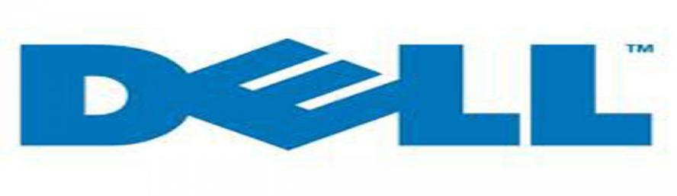

Dell traces its origins to 1984, when Michael Dell created Dell Computer Corporation, which at the time did business as PC'slimited, while a student of the University of Texas at Austin. The dorm-room headquartered company sold [IBM PC-compatible](https://en.wikipedia.org/wiki/IBM_PC_compatible) computers built from stock components. Dell dropped out of school to focus full-time on his fledgling business, after getting $1,000 in expansion-capital from his family. In 1985, the company produced the first computer of its own design, the *Turbo PC*, which sold for $795. PC's Limited advertised its systems in national computer magazines for sale directly to consumers and custom assembled each ordered unit according to a selection of options. The company [grossed](https://en.wikipedia.org/wiki/Gross_profit) more than $73 million in its first year of operation.

In 1986, Michael Dell brought in Lee Walker, a 51-year-old venture capitalist, as president and chief operating officer, to serve as Dell's mentor and implement Dell's ideas for growing the company. Walker was also instrumental in recruiting members to the board of directors when the company went public in 1988. Walker retired in 1990 due to health, and Michael Dell hired Morton Meyerson, former CEO and president of [Electronic Data Systems](https://en.wikipedia.org/wiki/Electronic_Data_Systems) to transform the company from a fast-growing medium-sized firm into a billion-dollar enterprise.

The company dropped the PC's Limited name in 1987 to become Dell Computer Corporation and began expanding globally. In June 1988, Dell's market capitalization grew from $30 million to $80 million from its June 22 [initial public offering](https://en.wikipedia.org/wiki/Initial_public_offering) of 3.5 million shares at $8.50 a share. In 1992, [Fortune](https://en.wikipedia.org/wiki/Fortune_(magazine)) magazine included Dell Computer Corporation in its list of the world's [500](https://en.wikipedia.org/wiki/Fortune_Global_500) largest companies, making Michael Dell the youngest CEO of a Fortune 500 company ever.

In 1993, to complement its own direct sales channel Dell planned to sell PCs at big-box retail outlets such as Wal-Mart, which would have brought in an additional $125 million in annual revenue. Bain consultant [Kevin Rollins](https://en.wikipedia.org/wiki/Kevin_Rollins) persuaded Michael Dell to pull out of these deals, believing they would be money losers in the long run.[[19]](https://en.wikipedia.org/wiki/Dell#cite_note-19) Margins at retail were thin at best and Dell left the reseller channel in 1994.[[20]](https://en.wikipedia.org/wiki/Dell#cite_note-mhhe.com-20) Rollins would soon join Dell full-time and eventually become the company President and CEO.

Features:

Dell:

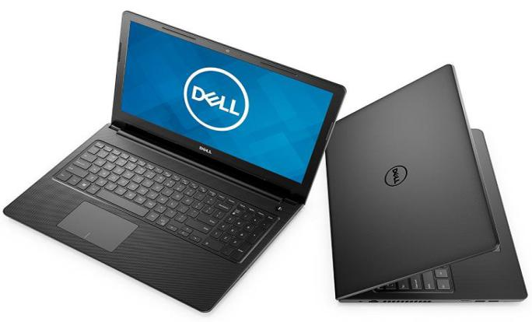

## Dell Inspiron 15 3576 (B566104WIN9) Core i5 8th Gen Windows 10 Laptop (8 GB, 1 TB HDD, 39.62 cm, Grey) Item Details

**Laptop Category**

* Condition New
* Laptop Type Notebook
* Lifestyle Gaming

**Manufacturer Details**

* Brand Dell
* Model Series Inspiron
* Model NumberB566104WIN9

**Operating System**

* OS Type Windows
* OS Name & Version Windows 10 Home
* OS Architecture64-bit

**Laptop Screen Specifications**

* Size15.6  Inches
* Type LED-Backlit
* Resolution1920 x 1080 pixels
* Ratio16:9

**Laptop Processor Details**

* Brand Intel
* Name Core i5
* Generation 8th Generation
* Processor Variant8250U
* Number Of Cores4
* Processor Speed1.6  GHz
* Maximum Turbo Speed3.4  GHz
* Cache6  MB

View Less

**Internal Memory**

* RAM8  GB
* Type Of RAMDDR4
* RAM Frequency2400  MHz

**Storage Specification**

* Type Of Storage HDD
* HDD Capacity 1TB
* Hard Disk Speed5400  rpm
* SSD Capacity No SSD

**Graphic Processor**

* Brand Intel
* Model UHD Graphics 620
* Type Integrated

**Sound**

* Speaker Type Built-in Speaker
* Audio Technology Waves Maxx Audio Pro
* Audio Jack3.5mm - Headphone/Microphone Combo Jack

**Ports & Slots**

* USB Types Supported USB 2.0    
  USB 3.1
* Number Of USB Ports1 x USB 2.0 | 2 x USB 3.1 Gen 1
* HDMI Type HDMI
* Number Of HDMI Ports1 x HDMI 1.4
* External Card Supported SD Card Reader (SD, SDHC, SDXC)
* Ethernet Supported Yes
* Ethernet SpecificationsRJ-45 Ethernet Port (10/100)

**Network Connectivity**

* Wi-Fi Supported Yes
* Wi-Fi Specifications802.11ac, Dual Band 2.4 and 5 Ghz, 1x1
* Bluetooth Supported Yes
* Bluetooth Specifications Bluetooth 4.1

**Laptop Camera Type**

* Camera Type Webcam
* Camera Resolution HD (720p)
* Camera Features Integrated widescreen Webcam with Single Digital Microphone

**Laptop Battery**

* Type Removable
* Technology Lithium-Ion
* Number Of Cells4  Cell
* Standard Battery Life40 WHr

**Plug Details**

* Power 45 Watt AC Adapter

**Product Aesthetics**

* Color Grey
* Color Family Grey

**In The Box**

* Main Product1 x Laptop U
* Accessories Charging Adapter

**Product Dimensions (Open)**

* Dimensions in CM (W x D x H)38.0 x 26.03 x 2.37
* Dimensions in Inches (W x D x H)14.96 x 10.25 x 0.93
* Weight2130  g
* Depth10.25  Inches
* Width14.96  Inches
* Height0.93  Inches
* Weight2.13  Kg

**After Sales & Services**

* Installation & Demo Not Applicable
* Standard Warranty Period12  Months

**Company Contact Information**

* Generic Name Laptop
* Manufacturer Name Dell

Architecture of **Processor**

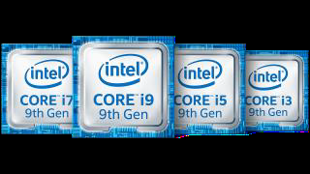

A processor is the logic circuitry that responds to and processes the basic instructions that drive a computer. The four primary functions of a processor are fetching, decode, execute and write back.

The basic elements of a processor:

The arithmetic logic unit (ALU), which carries out arithmetic and logic operations on the operands in instructions.

The floating point unit (FPU), also known as a math coprocessor or numeric coprocessor, a specialized coprocessor that manipulates numbers more quickly than the basic microprocessor circuitry can.

Registers, which hold instructions and other data. Registers supply operands to the ALU and store the results of operations.

L1 and L2 cache memory. Their inclusion in the CPU saves time compared to having to get data from random access memory (RAM).

Most processors today are multi-core, which means that the IC contains two or more processors for enhanced performance, reduced power consumption and more efficient simultaneous processing of multiple tasks (s*ee:* parallel processing). Multi-core set-ups are similar to having multiple, separate processors installed in the same 2

Computer, but because the processors are actually plugged into the same socket, the connection between them is faster.

The term *processor* is used interchangeably with the term central processing unit (CPU), although strictly speaking, the CPU is not the only processor in a computer. The GPU (graphics processing unit) is the most notable example but the hard drive and other devices within a computer also perform some processing independently. Nevertheless, the term *processor* is generally understood to mean the CPU.

The processor in a personal computer or embedded in small devices is often called a microprocessor. That term simply means that the processor's elements are contained on a single integrated circuitry (IC) chip.

The two main competitors in the processor market are Intel and AMD. 3 4

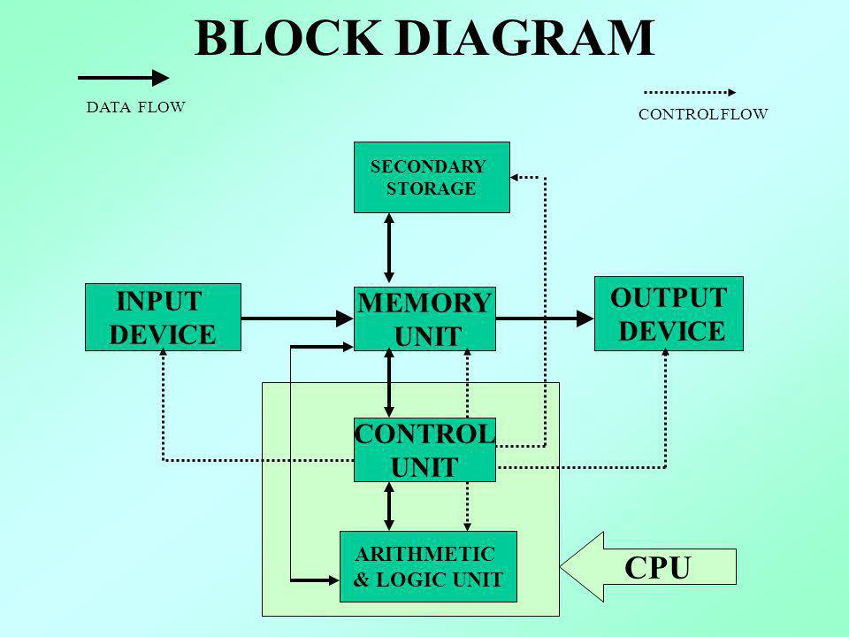

The architecture of the motherboard is also important in determining what hardware and software a computer system will support. The motherboard design is often called the "chipset" and defines what processor models and other components will work with the motherboard. For example, while two motherboards may both support x86 processors, one may only work with newer processor models. A newer chipset may also require faster RAM and a different type of video card than an older model.

NOTE: Most modern computers have 64-bit processors and chipsets, while earlier computers used a 32-bit architecture. A computer with a 64-bit chipset supports far more memory than one with a 32-bit chipset and can run software designed specifically for 64-bit processors. 6 7

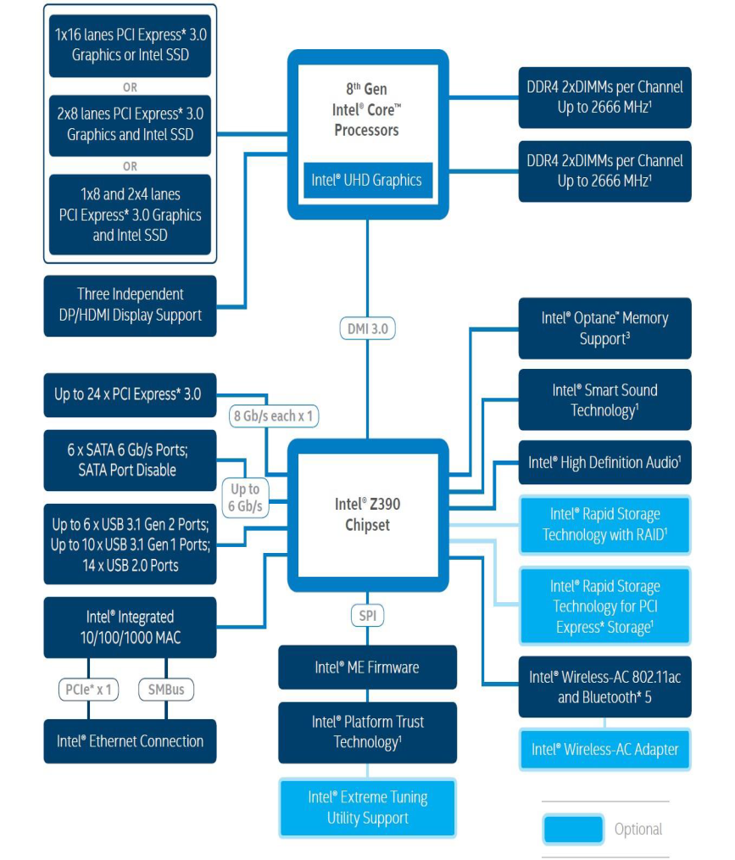

The word "architecture" typically refers to building design and construction. In the computing world, "architecture" also refers to design, but instead of buildings, it describes the design of computer systems. Computer architecture is a broad topic that includes everything from the relationship between multiple computers (such as a "client-server" model) to specific components inside a computer.

The most important type of hardware design is a computer's processor architecture. The design of the processor determines what software can run on the computer and what other hardware components are supported. For example, Intel's x86 processor architecture is the standard architecture used by most PCs. By using this design, computer manufacturers can create machines that include different hardware components, but run the same software. Several years ago, Apple switched from the PowerPC architecture to the x86 architecture to make the Macintosh platform more compatible with Windows PCs. 5

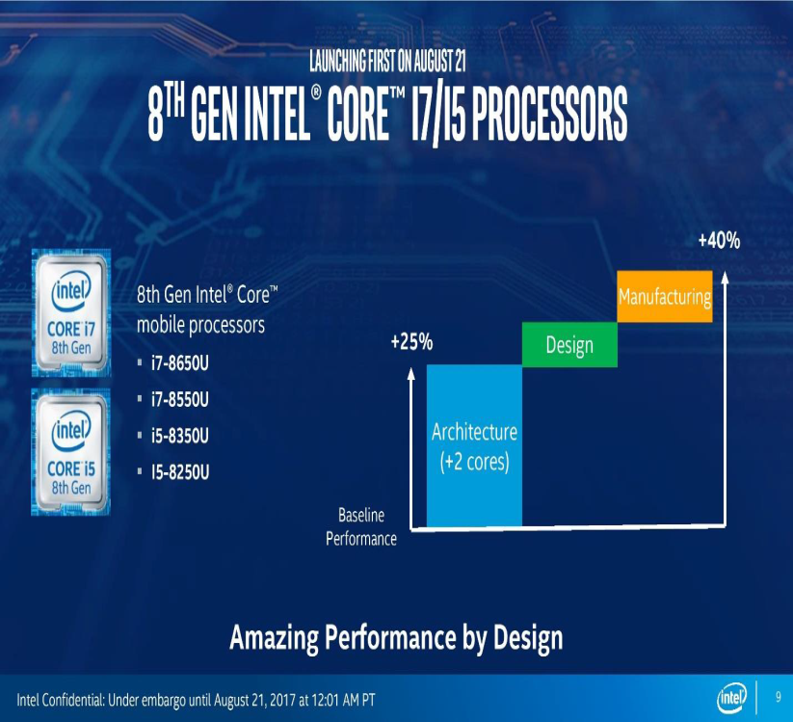

**GPU**

(**G**raphics **P**rocessing **U**nit) A programmable logic chip (processor) specialized for display functions. The GPU renders images, animations and video for the computer's screen. GPUs are located on plug-in cards, in a chipset on the motherboard or in the same chip as the CPU. A GPU performs parallel operations. Although it is used for 2D data as well as for zooming and panning the screen, a GPU is essential for smooth decoding and rendering of 3D animations and video. The more sophisticated the GPU, the higher the resolution and the faster and smoother the motion in games and movies. GPUs on stand-alone cards include their own memory, while GPUs built into the chipset or CPU chip share main memory with the CPU.

**Not Just Graphics Processing** Since GPUs perform parallel operations on multiple sets of data; they are increasingly used as vector processors for non-graphics applications that require repetitive computations. For example, in 2010, a Chinese supercomputer achieved the record for top speed using more than seven thousand GPUs in addition to its CPUs. 8 9

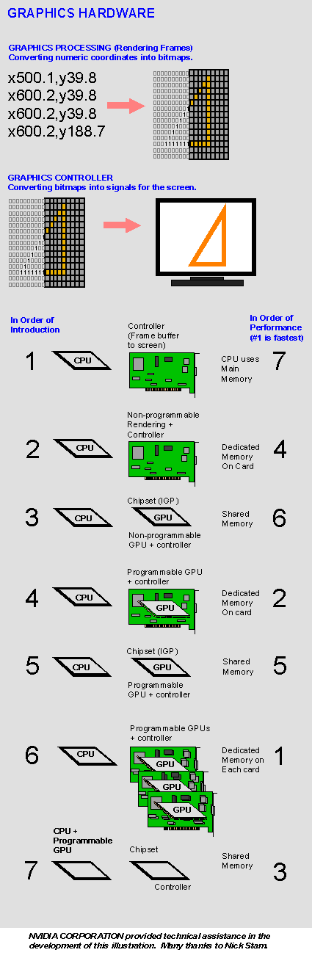

**Graphics Hardware Locations**

In a PC, graphics rendering originally took place in the CPU. Over time, functions were offloaded to separate circuits and then to GPUs either in separate cards, the PC's chipset or the CPU chip itself. See display adapter, integrated graphics and integrated GPU.

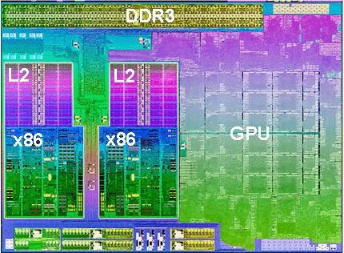

**An Integrated GPU**

This Trinity chip from AMD integrates a sophisticated GPU with four cores of x86 processing and a DDR3 memory controller. Each x86 section is a dual-core CPU with its own L2 cache.

**History of GPUs**

Specialized chips for processing graphics have existed since the dawn of video games in the 1970s. Graphics processing units came to high-performance enterprise computers in the late 1990s, and NVIDIA introduced the first GPU for personal computers, the GeForce 256, in 1999.

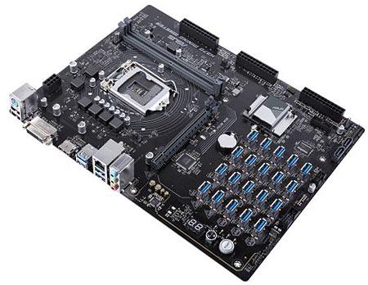

Over time, the processing power of GPUs made the chips a popular choice for other resource-intensive tasks unrelated to graphics. Early applications included scientific calculations and modeling; by the mid-2010s, GPU computing also powered machine learning and artificial intelligence software.

In 2012, NVIDIA released a virtualized GPU, which offloads graphics processing power from the server CPU in a virtual desktop infrastructure. Graphics performance has traditionally been one of the most common complaints among users of virtual desktops and applications, and virtualized GPUs aim to address that problem. 11



**RAM (Random Access Memory)**

RAM (Random Access Memory) is the hardware in a computing device where the operating system (OS), application programs and data in current use are kept so they can be quickly reached by the device's processor. RAM is the main memory in a computer, and it is much faster to read from and write to than other kinds of storage, such as a hard disk drive (HDD), solid-state drive (SSD) or optical drive.

Random Access Memory is volatile. That means data is retained in RAM as long as the computer is on, but it is lost when the computer is turned off. When the computer is rebooted, the OS and other files are reloaded into RAM, usually from an HDD or SSD.

What Random Access Memory is used for?

Because of its volatility, Random Access Memory can't store permanent data. RAM can be compared to a person's short-term memory, and a hard drive to a person's long-term memory. Short-term memory is focused on immediate work, but it can only keep a limited number of facts in view at any one time. When a person's short-term memory fills up, it can be refreshed with facts stored in the brain's long-term memory.

A computer also works this way. If RAM fills up, the computer's processor must repeatedly go to the hard disk to overlay the old data in RAM with new data. This process slows the computer's operation. 12

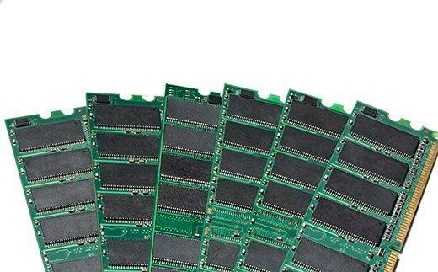

RAM modules

A computer's hard disk can become completely full of data and unable to take any more, but RAM won't run out of memory. However, the combination of RAM and storage memory can be completely used up.

How does RAM work?

The term *random access* as applied to RAM comes from the fact that any storage location, also known as any memory address, can be accessed directly.

Originally, the term *Random Access Memory* was used to distinguish regular core memory from offline memory.

Offline memory typically referred to magnetic tape from which a specific piece of data could only be accessed by locating the address sequentially, starting at the beginning of the tape. RAM is organized and controlled in a way that enables data to be stored and retrieved directly to and from specific locations.

Other types of storage -- such as the hard drive and CD-ROM -- are also accessed directly or randomly, but the term *random access* isn't used to describe these other types of storage.

RAM is similar in concept to a set of boxes in which each box can hold a 0 or a 1. Each box has a unique address that is found by counting across the columns and down the rows. A set of RAM boxes is called an array, and each box is known as a cell.

To find a specific cell, the RAM controller sends the column and row address down a thin electrical line etched into the chip. Each row and column in a RAM array has its own address line. Any data that's read flows back on a separate data line.

RAM is physically small and stored in microchips. It's also small in terms of the amount of data it can hold.

A typical laptop computer may come with 8 gigabytes of RAM, while a hard disk can hold 10 terabytes.

RAM microchips are gathered together into memory modules, which plug into slots in a computer's motherboard. A bus, or a set of electrical paths, is used to connect the motherboard slots to the processor.

A hard drive, on the other hand, stores data on the magnetized surface of what looks like a vinyl record. And, alternatively, an SSD stores data in memory chips that, unlike RAM, are nonvolatile, don't depend on having constant power and won't lose data once the power is turned off.

Most PCs enable users to add RAM modules up to a certain limit. Having more RAM in a computer cuts down on the number of times the processor must read data from the hard disk, an operation that takes longer than reading data from RAM. RAM access time is in nanoseconds, while storage memory access time is in milliseconds. Types of Random Access Memory 14

RAM comes in two primary forms:

**Dynamic Random Access Memory (DRAM)** makes up the typical computing device's RAM and, as was previously noted, it needs that power to be on to retain stored data.

Each DRAM cell has a charge or lack of charge held in an electrical capacitor. This data must be constantly refreshed with an electronic charge every few milliseconds to compensate for leaks from the capacitator. A transistor serves as a gate, determining whether a capacitor's value can be read or written.

**Static Random Access Memory (SRAM)** also needs constant power to hold on to data, but it doesn't need to be continually refreshed the way DRAM does.

In SRAM, instead of a capacitor holding the charge, the transistor acts as a switch, with one position serving as 1 and the other position as 0. Static RAM requires several transistors to retain one bit of data compared to dynamic RAM which needs only one transistor per bit. As a result, SRAM chips are much larger and more expensive than an equivalent amount of DRAM.

However, SRAM is significantly faster and uses less power than DRAM. The price and speed differences mean static RAM is mainly used in small amounts as cache memory inside a computer's processor. 15

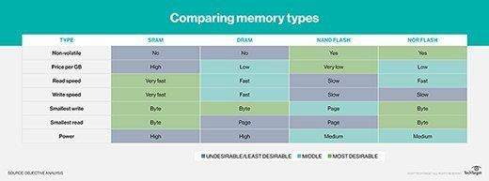

History of RAM: RAM vs. SDRAM

RAM was originally asynchronous because the RAM microchips had a different clock speed than the computer's processor. This was a problem as processors became more powerful and RAM couldn't keep up with the processor's requests for data.

In the early 1990s, clock speeds were synchronized with the introduction of synchronous dynamic RAM, or SDRAM. By synchronizing a computer's memory with the inputs from the processor, computers were able to execute tasks faster.

However, the original single data rate SDRAM (SDR SDRAM) reached its limit quickly. Around the year 2000, double data rate synchronous Random Access Memory (DDR SRAM) was developed. This moved data twice in a single clock cycle, at the start and the end.

DDR SDRAM has evolved three times, with DDR2, DDR3 and DDR4, and each iteration has brought improved data throughput speeds and reduced power use. However, each DDR version has been incompatible with earlier ones because, with each iteration, data is handled in larger batches.

The JEDEC Solid State Technology Association has been working on the fifth generation of DDR technology, or DDR5 SDRAM, for several years, and it plans to release the full standard in June 2018. 16

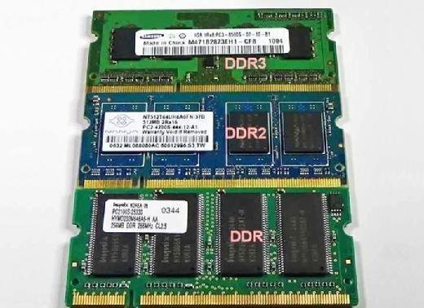

GDDR SDRAM

Graphics double data rate (GDDR) SDRAM is used in graphics and video cards. Like DDR SDRAM, the technology enables data to be moved at various points in a CPU clock cycle. However, it runs at higher voltages and has less strict timing than DDR SDRAM.

With parallel tasks, such as 2D and 3D video rendering, tight access times aren't as necessary, and GDDR can enable the higher speeds and memory bandwidth needed for GPU performance.

Similar to DDR, GDDR has gone through several generations of development, with each providing more performance and lower power consumption. GDDR6 is the latest generation of graphics memory. 17

**Control unit**

A control unit (CU) handles all processor control signals. It directs all input and output

flow, fetches code for instructions from microprograms and directs other units and

models by providing control and timing signals. A CU component is considered the

processor brain because it issues orders to just about everything and ensures correct

instruction execution.

CU functions are as follows:

• Controls sequential instruction execution

• Interprets instructions

• Guides data flow through different computer areas

• Regulates and controls processor timing

• Sends and receives control signals from other computer devices

• Handles multiple tasks, such as fetching, decoding, execution handling and

storing results

CUs are designed in two ways:

• Hardwired control:

Design is based on a fixed architecture. The CU is made up of

flip-flops, logic gates, digital circuits and encoder and decoder circuits that are

wired in a specific and fixed way. When instruction set changes are required,

wiring and circuit changes must be made. This is preferred in a reduced

instruction set computing (RISC) architecture, which only has a small number of

instructions.

• Microprogram control:

Microprograms are stored in a special control memory and are

based on flowcharts. They are replaceable and ideal because of their simplicity.

• With a single-level control store:

In this, the instruction opcode from the instruction register is sent to the control store

address register. Based on this address, the first microinstruction of a microprogram

that interprets execution of this instruction is read to the microinstruction register.

This microinstruction contains in its operation part encoded control signals, normally

as few bit fields. In a set microinstruction field decoders, the fields are decoded. The

microinstruction also contains the address of the next microinstruction of the given

instruction microprogram and a control field used to control activities of the

microinstruction address generator.

The last mentioned field decides the addressing mode (addressing operation) to be

applied to the address embedded in the ongoing microinstruction. In microinstructions

along with conditional addressing mode, this address is refined by using the processor

condition flags that represent the status of computations in the current program. The

last microinstruction in the instruction of the given microprogram is the

microinstruction that fetches the next instruction from the main memory to the

instruction register.

With a two-level control store:

In this, in a control unit with a two-level control store, besides the control memory for

microinstructions, a nano-instruction memory is included. In such a control unit,

microinstructions do not contain encoded control signals. The operation part of

microinstructions contains the address of the word in the nano-instruction memory,

which contains encoded control signals. The nano-instruction memory contains all

combinations of control signals that appear in microprograms that interpret the

complete instruction set of a given computer, written once in the form of nano-

instructions.

In this way, unnecessary storing of the same operation parts of

microinstructions is avoided. In this case, microinstruction word can be much shorter

than with the single level control store. It gives a much smaller size in bits of the

microinstruction memory and, as a result, a much smaller size of the entire control

memory. The microinstruction memory contains the control for selection of

consecutive microinstructions, while those control signals are generated at the basis of

nano-instructions. In nano-instructions, control signals are frequently encoded using 1

bit/ 1 signal method that eliminates decoding.